009 TypeScript - assignment operators

TypeScript Kata List – Blog Page

[TypeScript Kata List on GitHub](https://github.com/robertdunaway/katas-typescript)

# Duration

10 minutes

# Brief

Using assignment operators (=, +=, -=, *=, /=, %=).

### For More Information

BING/GOOGLE: “TypeScript assignment operators”

# Instructions

Get tutorial folder or the entire katas-typescript repo.

Open the [before/*.sln] file and execute the kata.

Feel free to execute this kata multiple times because repetition creates motor memory.

# Github

* Before (start kata with this)
  + https://github.com/robertdunaway/katas-typescript/tree/master/009%20TypeScript%20-%20assignment%20operators/before
* After
  + https://github.com/robertdunaway/katas-typescript/tree/master/009%20TypeScript%20-%20assignment%20operators/after

# Kata

Create two variables of type number for working with assignment operators

var a: number = 10;

var b: number = 5;

Output to the console the results of assignment operators (=, +=, -=, *=, /=, %=)

[highlight below for one possible answer]

var a: number = 10;

var b: number = 5;

var result: number = 0;

result = a + b;

console.log('result = a + b; // result =' + result);

result += a;

console.log('result += a; // result =' + result);

result -= a;

console.log('result -= a; // result =' + result);

result *= 2;

console.log('result *= 2; // result =' + result);

result /= a;

console.log('result /= a; // result =' + result);

result %= 2;

console.log('result %= 2; // result =' + result);

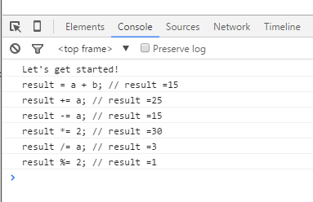

# Next

Take a few minutes and imagine more examples.